

FALCON’s Response to RFQ
FedEx for the supply of SWEDI Sorter of Throughput 4000 PPH
December 20, 2022

Kind Attention –

Mr. Turab Rahaman

FedEx Express

Offer Ref: F22-00362 Date 20/12/2022

Subject – Proposal for the supply of SWEDI sorter of throughput 4000PPH.

Dear Sir,

We are pleased to submit our Offer for Supply of SWEDI Sorter
As you will note, we have studied your requirements in great depth and, along with the information collected during the workshops and calls with you, we have put together a detailed technical proposal
In subsequent sections, we have highlighted the capabilities and experiences of Falcon Autotech as well as the capabilities of the proposed software.
To conclude, I would like to add my personal commitment, on behalf of Falcon Autotech. As we move through the RFP process, please do not hesitate to contact me and my team. We will be pleased to assist you for any further information or clarifications that you might have.
tails
Contact Person : Ajay Kumar
Title : Assistant sales manager
Mobile : +91-9711619996
Email : ajay.kumar@falconautoonline.com

Company Details
Company Name : Falcon Autotech Pvt. Ltd.
Regd. Office : 57, Nimri Colony, Double Storey Flats, Delhi – 110052
Website : www.falconautotech.com
LinkedID :

Contents
1. Glossary 5
2. Company Profile 6
3. Falcon’s Experience and Achievements in Sortation Space Globally 14
4. Layout View 15
Process Note 15
5. Handled Parcel Spectrum 16
a. Parcel size loadable on the sorter 16
b. Parcels to be loaded on Sorter shall have the following characteristics: 16
c. Parcel not loadable on the sorter 17
d. Pictures of Sortable Shipments 17
6. Key Modules 18
7. Key Component Makes 23
8. Proposed System Technical Details. 23
9. Price Schedule 25
10. Warranty Period 25
11. Delivery Schedule 25
12. Exclusions 26

Response Quotation for Swivel Wheel Diverts

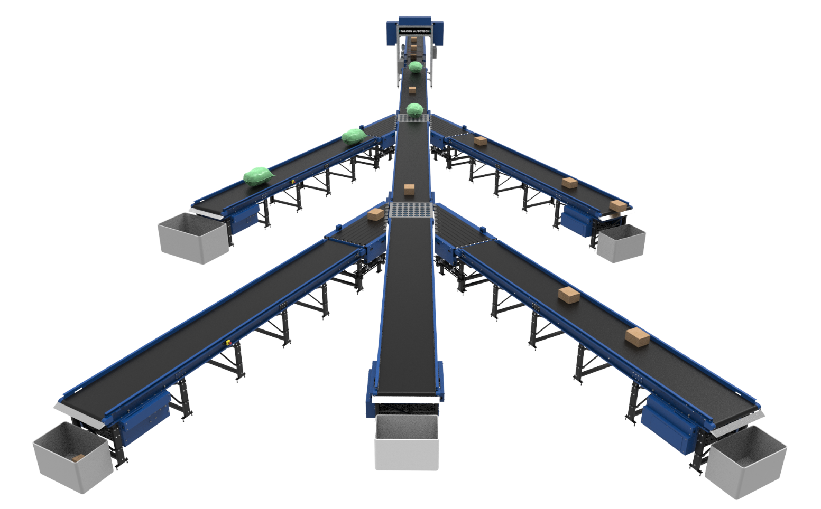

Proposal Reference - F22-00231

Falcon Autotech Private Limited
Plot No 308 & 309
Ecotech-1 Extension, Greater Noida
Uttar Pradesh- 201308
India.

Contact – Ajay kumar
Assistant Manager
Mob - +91-9711619996
ajay.kumar@falconautoonline.com

Glossary

S. No. | Term | Description
1 | RFQ | Request For Quote
2 | PPH | Parcels Per Hour
3 | ICR | Intelligent Character Recognition
4 | PLC | Programmable Logic Controller
5 | IT | Information Technology
6 | BOQ | Bill Of Quantity
7 | I/O | Input/ Output
8 | PC | Personal Computer
9 | UPS | Uninterrupted Power Supply

Company Profile
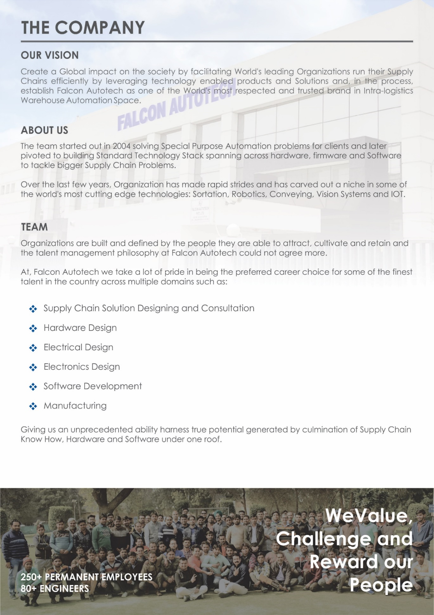

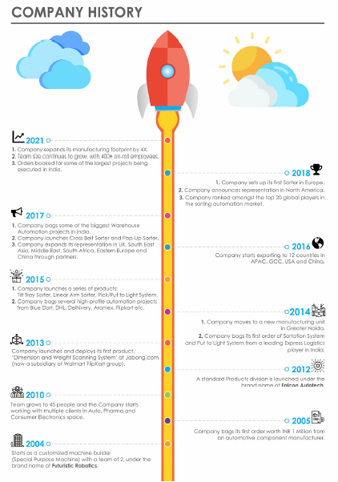

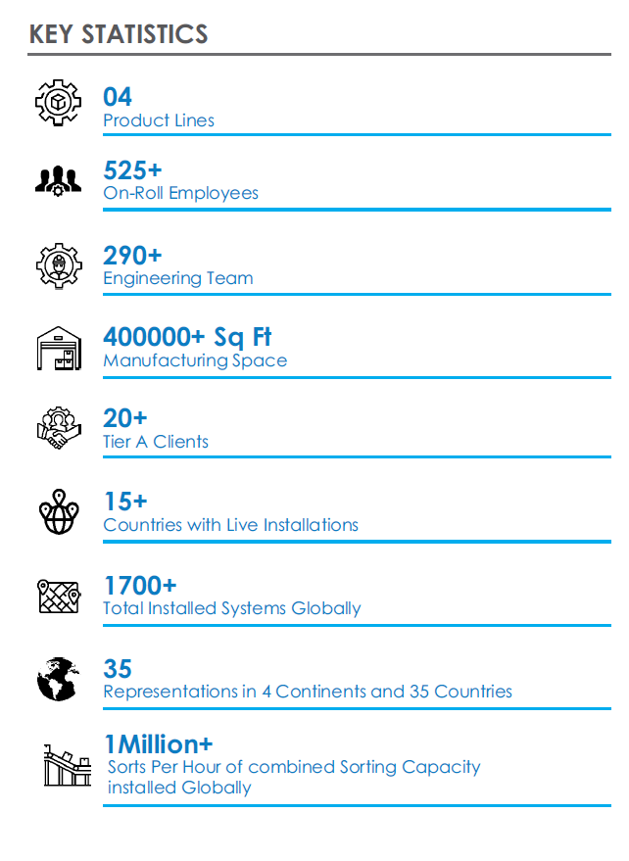

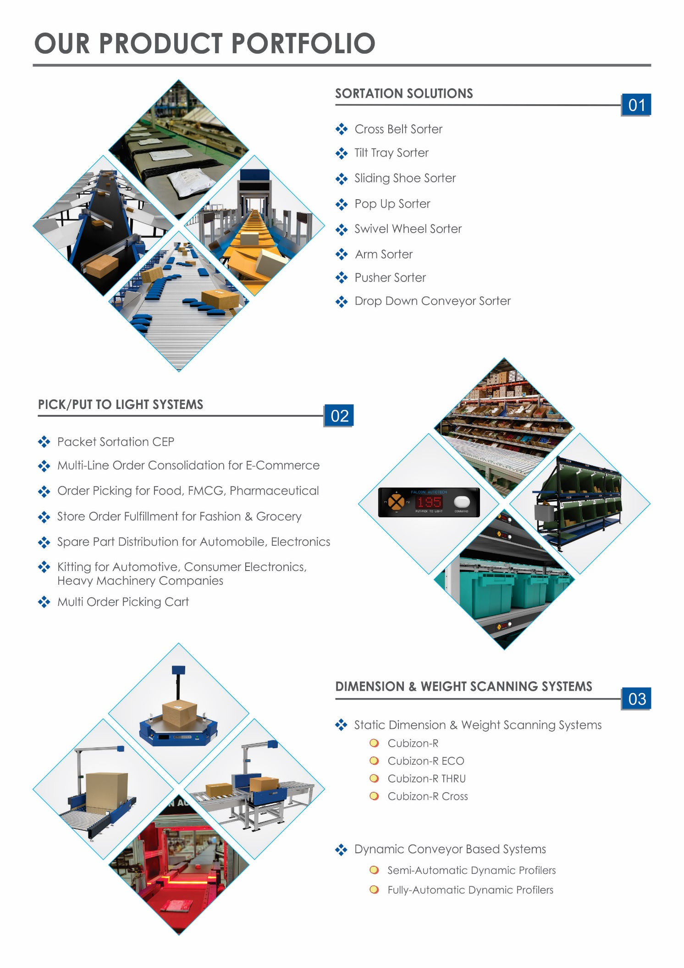

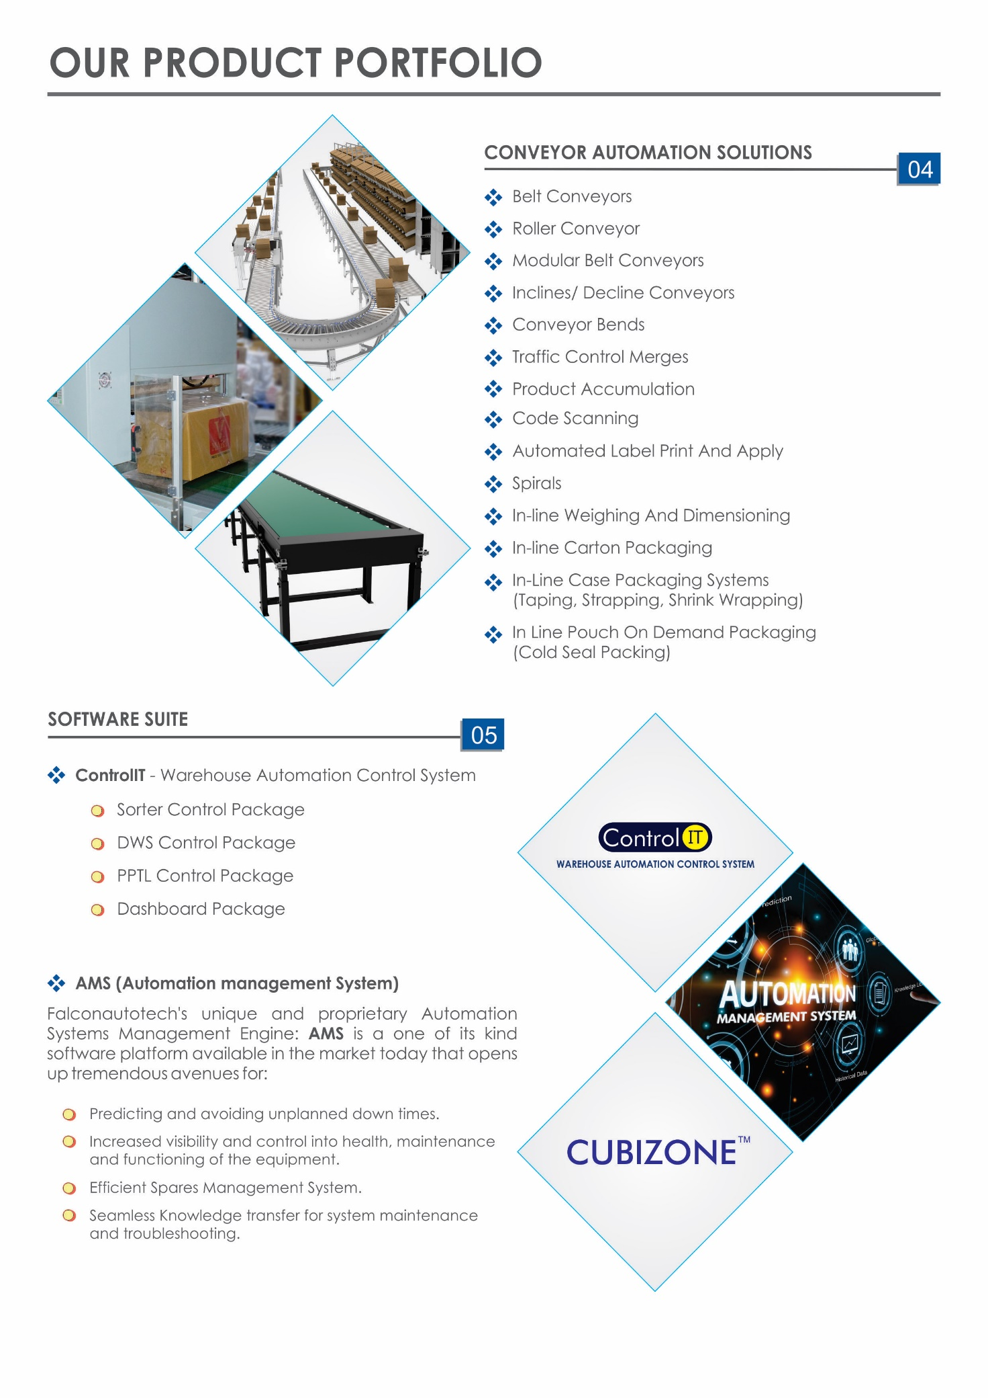

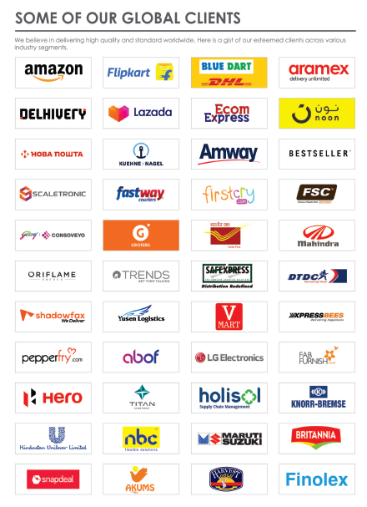

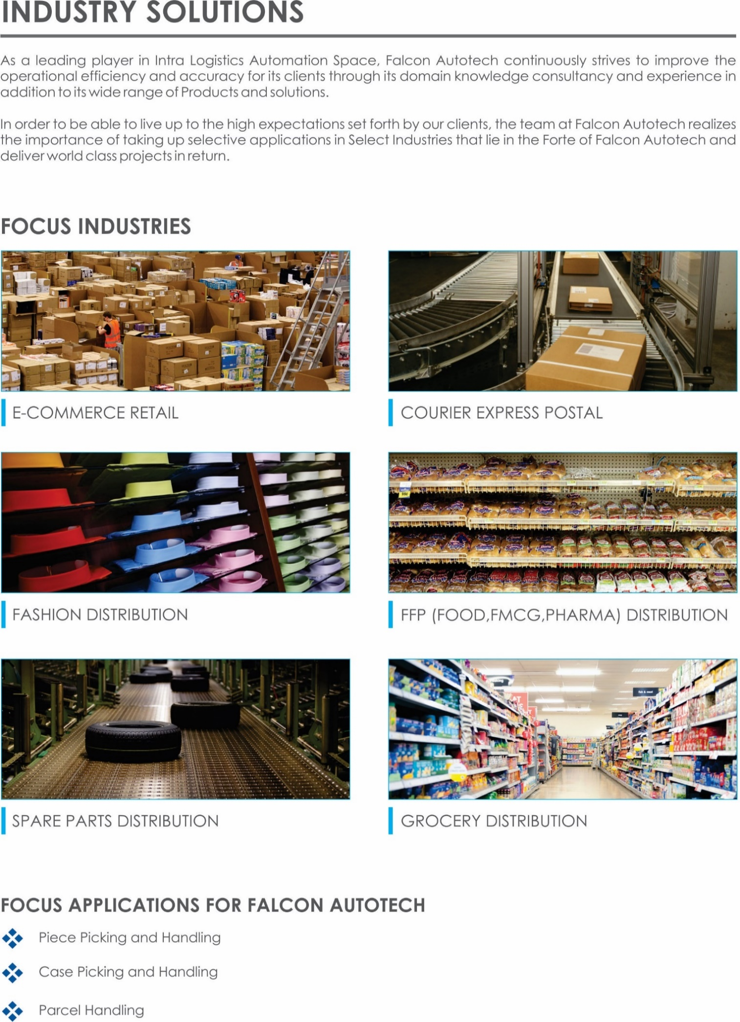



Falcon’s Experience and Achievements in Sortation Space Globally
- Ranked among Top 20 Sortation System Suppliers globally. Only company from APAC/EMEA Region.
- Currently possess one of the World’s largest portfolio in Sortation Technologies: 7 In-house technologies.
- Total installed capacity of 6 Million Parcels per day worldwide.
- Only company to be able to offer a Fully Integrated AMS.
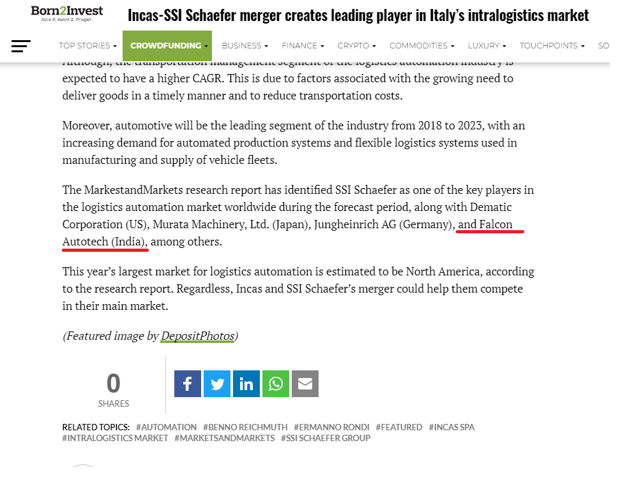

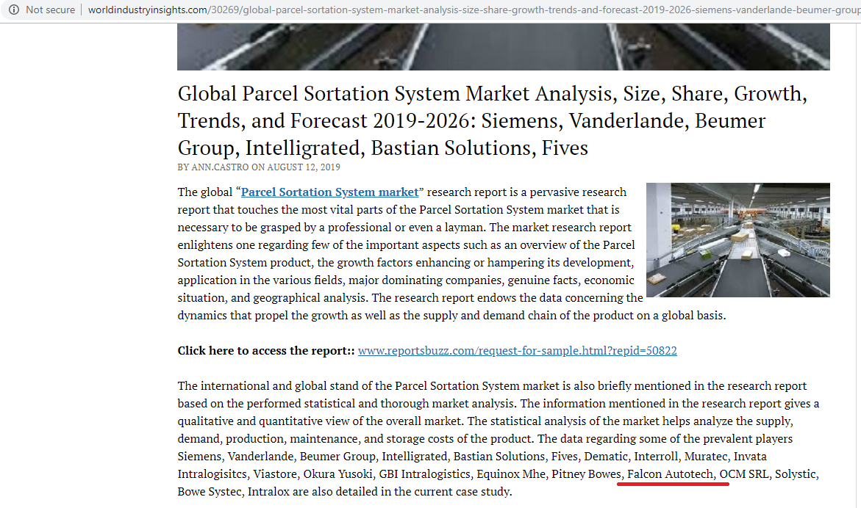

Kind Attention –

Layout View
Upper deck SWEDI (Future)
Lower Deck SWEDI
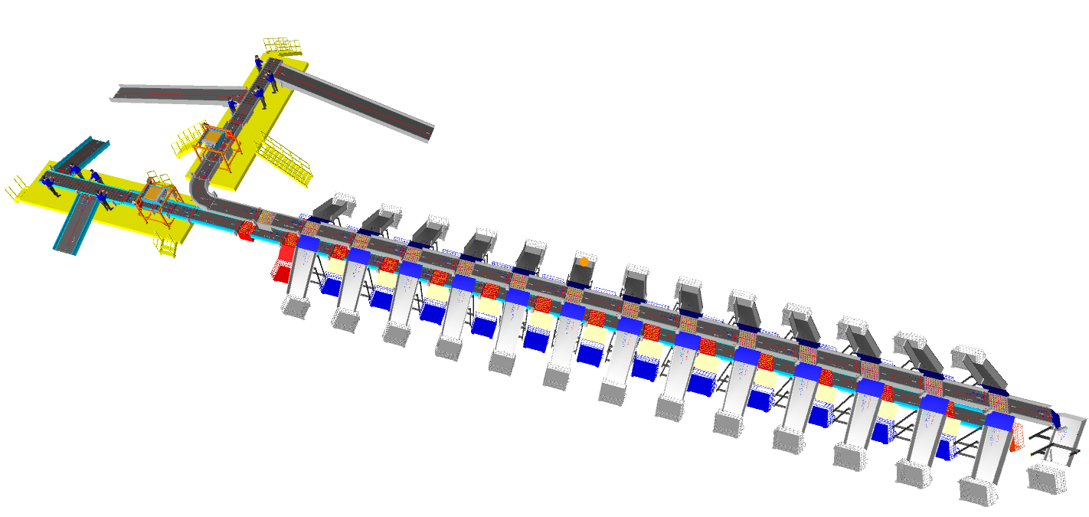

Process Note

- In a double deck SWEDI system, lower deck sorter is running at the height of 1000mm from the ground level and upper deck sorter running at the height of 2500 from ground level
- The parcels are loaded into the bulk feeding conveyor/launch pad.
- The Parcels are singulated and orientated (barcode facing up) & placed over Loading Conveyor by the operators after picking from launch pad.
- While parcels are on run, barcodes are scanned under Barcode Scanning Tunnel and relative Chute is assigned to the scanned parcels.
- Once parcel reach the assigned chute, relative Swivel Wheel unit is actuated & parcel will be discharged & collected in trolley from transfer plate.
- Rejected Parcels will be conveyed till end of Conveyor Line & get collected in Cage Bin.

Handled Parcel Spectrum
Dimensions Minimum Maximum

Parcel size loadable on the sorter

Product Range
Transported Items | Size | Length (mm) | Width (mm) | Height (mm) | Weight (Kg)
Carton boxes, Poly Bags | Maximum | 900 | 500 | 500 | 35
 | Minimum | 150 | 150 | 50 | 0.5

Parcels to be loaded on Sorter shall have the following characteristics:

- Centre of Gravity of item must not move during conveyance or sorting.
- Item must not have magnetic content, otherwise behavior of parcel cannot be guaranteed.
- Liquid or fragile material, to avoid breaking, spillage or leakage, such as wine bottles, metal cans of paint are designated as non- conveyable items.
- Parcels shall be perfectly and safely packaged: protrusion or open surfaces are not allowed.
- Plastic ropes shall be perfectly adherent to the surface of the package.
- Loose parts on loads and load carriers, such as adhesive tape, stickers, slips of paper, straps, wrap foil etc. are designated as non- conveyable items.
- All items with the risk of being damaged during the transport on an automatic sorting system or
damaging the sorting system. They must be robust enough to avoid disintegration of container material and loose of contents in the sorting process.
- Item packaging shall have enough grip to be handled on the belts during the acceleration and
referencing phases.
- Items shall not have slippery surfaces and must be able to withstand acceleration of the items on the belt during the start-stop phases (accelerations up to 0.5 g shall be assured without any sliding or tumbling of the items on the belt conveyor).
- The parcels must have at least one flat and regular surface providing enough stability during conveyance.
- Unstable items with a risk to roll or tumble on the sorting system, such as spherical or cylindrical items
- All shapes are permitted except spherical, cylindrical, or alike unstable items & shapes.
- All usual packaging materials are permitted (including paper, carton, plastics, plastic foil, rope, tape, textile, and wood)

Parcel not loadable on the sorter

All products that are not within the range as described here, are considered non- conveyable products, and must be taken out of the main sorter flow by the operators.

- Items that have a spherical or cylindrical shape.
- Items that are packed in material that can damage the conveyors or the sorter.
- Items that have sharp points (e.g. Nails) or sharp edges, that can damage the conveyors or the sorter.
- Fragile parcels with contents not sufficiently secured
- Items that have been classified as dangerous are designated.
- Wet items are designated.
- Items with anti-slip treatment.
- Items with protruding parts.
- Items with sharp edges.
- Inadequately packed items that could be damaged during automatic transportation.
- Electrostatically loaded items.

Pictures of Sortable Shipments

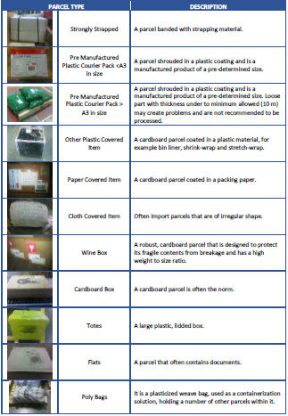

Key Modules

  - Automatic Feedlines
Fully automatic feedline is used in the system to induct parcels directly on to the sorter
Upper deck feedlines( Future )
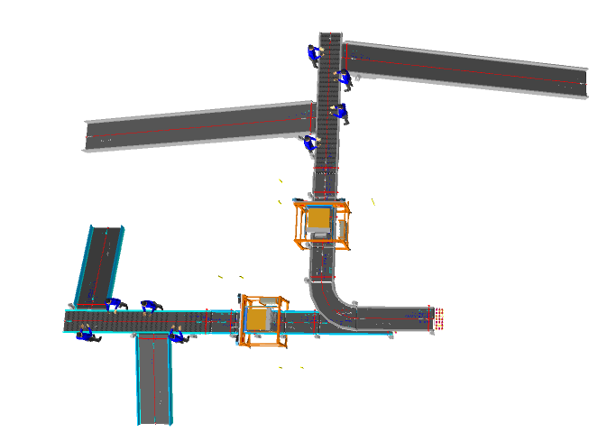
Lower deck Feedlines
Feedlines consists of below components
    - Shipment Loading Conveyor
It’s a approx. 3 m long. Powered Belt Conveyor for Shipment Loading. It is running at approx. 400 mm from ground Level.
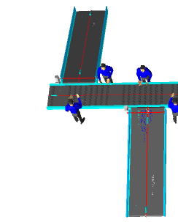
Lower Deck Loading conveyors / Bulk feeding conveyors.

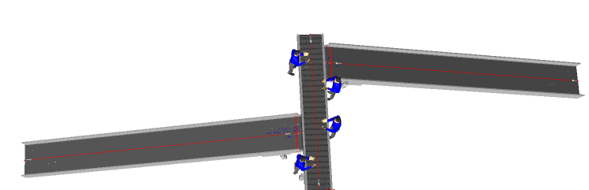
Upper deck Loading conveyor / Bulk feeding conveyor (Future Scope)

  - 6.1.2 Orientation Conveyor.

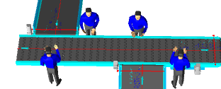

It’s a approx. 6 m long. Powered Belt Conveyor for Shipment Orientation running at approx. 800 mm from ground Level.
    - Spacing Conveyor
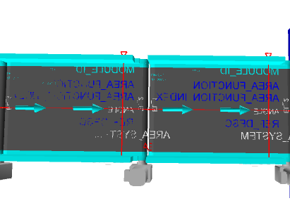
It’s a Special Conveyor, used to Create space between Parcels

    - Buffer and Output Conveyor
It ’s a Special Conveyor, used to Create space between Parcels
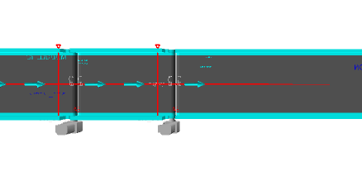

  - Automatic Barcode Scanning
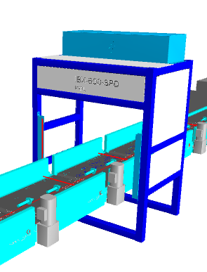
System is Integrated with Automated Line Scan Camera Technology (Sick ICR) for scanning 1D & 2D Barcodes

  - Sorter: Swivel Wheel Divert
Swivel Wheel Diverter (SWEDI) is a non-impact sortation module for linear sortation lines, ideal for medium volume sort centres. SWEDI's modular design allows it to save space while also allowing for future expansion of sorting point
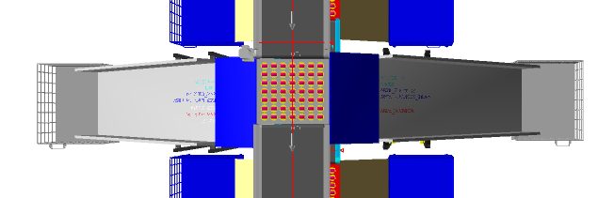
Technical specifications of SWEDI Unit

Items | Make
SWEDI Unit’s Dimensions | 1055 mm (L) x 915 mm (W)
Load Capacity | 35 KG
Throughput (Upper deck) (Future) | 5000 PPH
Throughput (Lower deck) | 5000 PPH
Conveying Drive Unit | 48V, 50 Watt DC powered smart roller
Diverting Drive Unit | Servo Motor; 220V, 50HZ, 750W, Single Phase
Conveying Speed | Up to 120 m/min
Diverting Angle | 90 Degrees at double sides
Frame Material | MS Powder Coated Steel Frame
Stand Support | MS Powder Coated Steel Frame
PLC | Siemens
Servo Motor | Delta
Noise Level | <75 Db when measured from 1 m in a silent warehouse.

  - Sliding Chutes
Parcels are collected in the in trolley with the help of sliding chute. The chutes are equipped with Chute full sensors and tower lamps.

  - 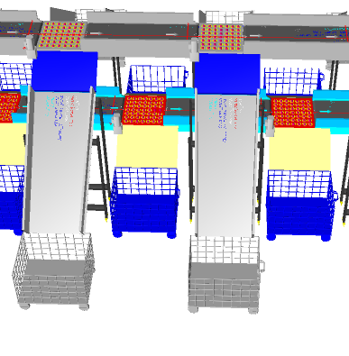
  - Steel works.


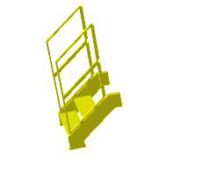
- Mezzanine 36SQM (Approximately)
- Ladders 3 no’s

Key Component Makes

S. No. | Description | Makes
1 | PLC | Siemen's
2 | HMI | Siemen's
3 | Control Cabinet & Accessories | BCH / Rittal
4 | Drives | Allen Bradely/ Lenze/ Siemen's
5 | Drive Motor and Gearbox | SEW/ Bonfigloili
6 | Sensors | Sick, P&F
7 | Bearings | SKF, NBC, NTN
8 | PVC Belt | Forbo, Derko,
9 | Rollers Make | Pulse/ Falcon
10 | Automatic Barcode Scanners | SICK/ Cognex
11 | Handheld Scanners | Motorola/ Honeywell

Proposed System Technical Details.

Mechanics
Pos. | Qty. | Description | Value
FM1 | 1 | Conveyor Automation (Upper deck) (Future)
 |  | 2 x Launch pad; L-10 m  1 x Buffer conveyor L-3  1 x Scanning Conveyor; L-1 m  2 x Spacing Conveyor | Width- 1500.  Ht.3500
1 x Weighing.
1 X 90 degree turn
FM2 | 1 | Falcon Sorter-Swivel Wheel Diverter (Upper deck) (Future)
 |  | System Width | 915 mm
 |  | System Length | 1055 mm
 |  | 13 x Powered Belt Conveyor: Total Length- 30 m
1 x Automatic Barcode Scanning System.
1 X VMS
14 X Swivel Wheel Divert Units.
25 X Sliding chute.
01 X Rejection.
01 X Sort fail

FM3 | 1 | Conveyor Automation (Lower deck).  2 x Launch Pad; L- 3 m  1 x Buffer conveyor L-3  1 x Scanning Conveyor; L-1 m  2 x Spacing Conveyor.  1 X Weighing. | Width- 1500  Ht.-800
FM4 | 1 | Falcon Sorter-Swivel Wheel Diverter (Lower deck)  System Width  System Length  13 x Powered Belt Conveyor: Total Length- 28 m  1 x Automatic Barcode Scanning System  1 X VMS  14 X Swivel Wheel Divert Units.  25 X Sliding chutes.  1 X Rejection  1 X Sort fail | 915 mm  1055 mm
Controls
FC1 | 1 | Controls, IT and Wiring
 |  | Software Package
 |  | Control Panels
 |  | Sorter Control | Included
 |  | Electrical & Control Hardware
 |  | Switches
 |  | Drive panels
 |  | Operator Panels
 |  | Internal & Field Wiring

Price Schedule
Below chapter consists of Price of Falcon’s Mechanics and Controls.
S. No. | Items (Lower Deck) | Price (USD)
1 | Feedline and Sorter | $ 834,090
2 | Chutes | $ 41,963
3 | Controls, IT and Wiring | $ 10,903
4 | Project Management and Engineering Charges | $ 23,546
5 | Packaging & forwarding | $ 44,359
6 | Steelwork | $ 10,505
Grand Total |  | $ 965,366

Total Price is to be understood
- Including Packing & Forwarding Charges
- Excluding Installation & Commissioning Charges
- Freight- Excluded
- Taxes Extra as applicable
- Unloading in Client’s Scope
- Laydown Area to be provided by MAFA

Warranty Period
Falcons offered System comes with a standard warranty of 1 year and post completion of warranty, customer can opt for Extended warranty.

Delivery Schedule

50 to 52 weeks Ex-Works, Greater Noida from the date of PO, Advance, and DAP.

Exclusions
The scope of supply includes all parts which are defined in the Supplier’s quotation.

All other parts which are not defined in the Supplier’s quotation do not belong to the Supplier’s scope of supply and are excluded. The following parts are also excluded:

- Server PC & Server Rack
- Construction Power
- Steel Works- If not specified
- Collection Bin
- Building infrastructure; building structure, doors, fire exits, levelling devices, building extinguisher and fire alarm system, building heating and lighting system.
- Electrical power supply and wiring to the main control cabinets
- UPS for Controls and Drives
- Electrical Power for Installation
- Network Cabling up to the Main Server Rack
- Intermediate wiring to parts which are to be supplied by the Purchaser/others
- Emergency/Uninterruptable power supply
- Fire-alarm and fire protection devices
- Traffic and route markings
- Laydown Area
- Ram protection devices
- Cat walks, bridges, maintenance aisles and platforms
- Assembly tools like forklifts and hoisting machines
- All kind of network incl. Local Area Network (LAN/WLAN), exceeding the scope described in Scope of Supply
- Any Kind of Civil work
- Any adjustment of the Supplier’s scope of supply to local rules and regulations
- X-Ray machines
- Roller cages/ Pallets
- Simulation and 3D animation of the sorter system
- Interface with other equipment not specified in this offer.
- Provision of facilities for the control room (furniture, air conditioning, heating, etc.).
- The supply and installation of fencing around the different corridors.
- Any item specifically indicated as not forming part of the subject matter of the Seller's supply in the offer documentation.

